**BURGER BASH**

**1.Database and table creation**

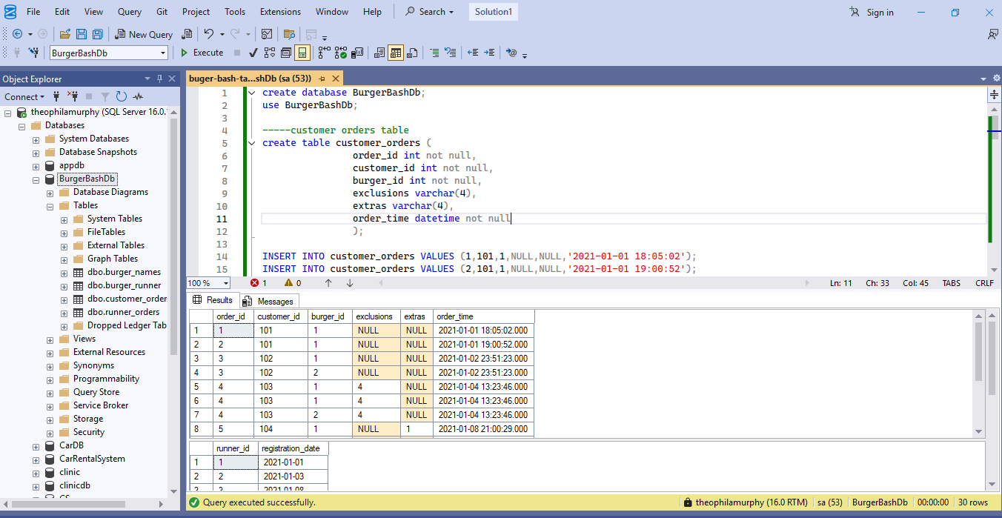

**2.Case study Questions**

**1. How many burgers were ordered?**

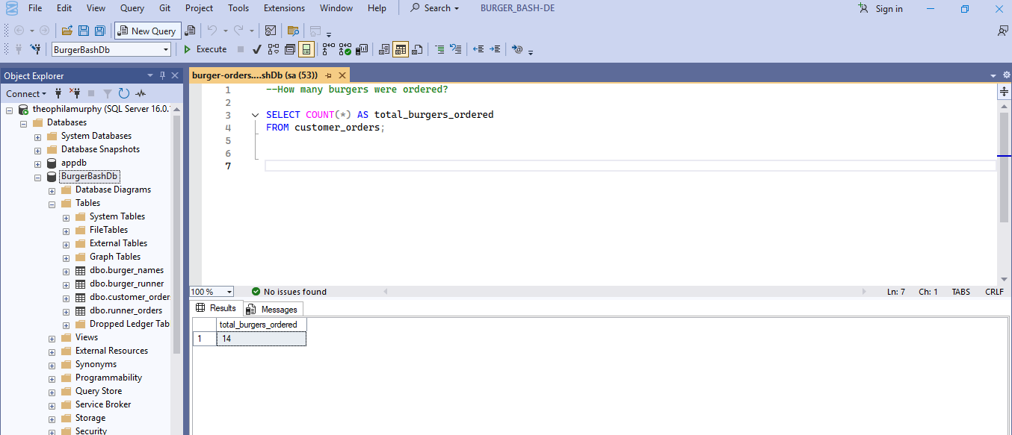

**2. How many unique customer orders were made?**

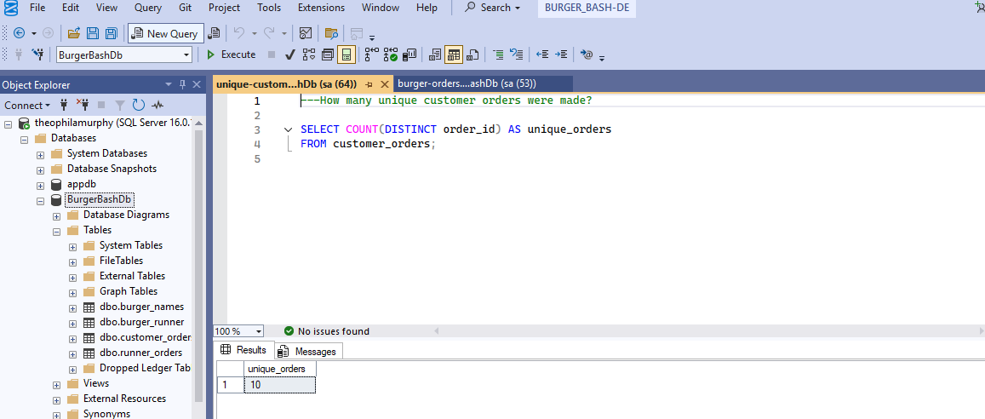

**3. How many successful orders were delivered by each runner?**

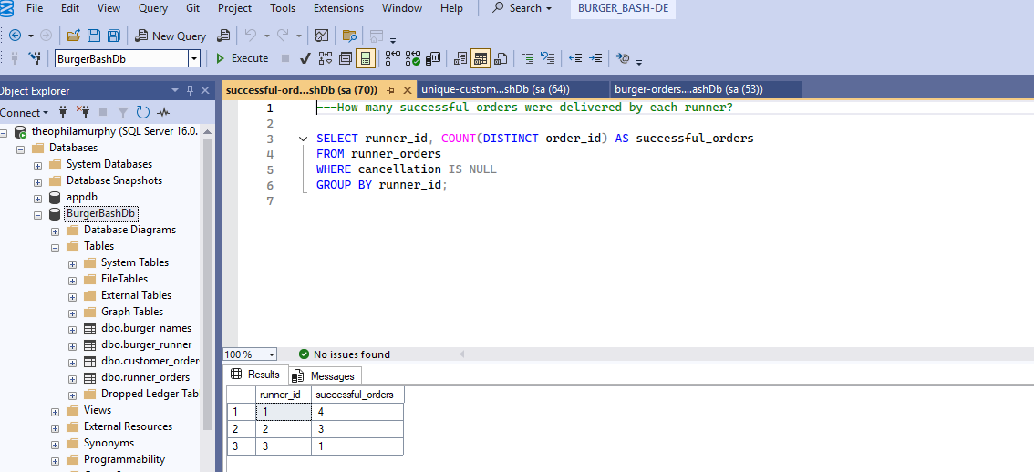

**4. How many of each type of burger was delivered?**

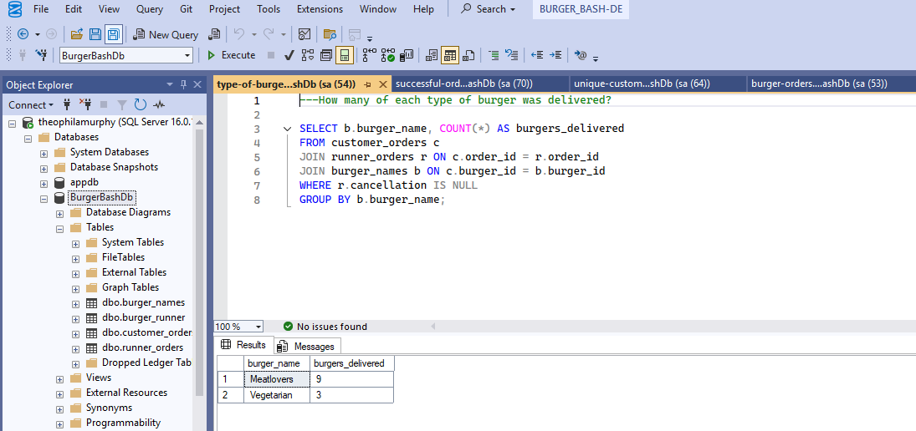

**5. How many Vegetarian and Meatlovers were ordered by each customer?**

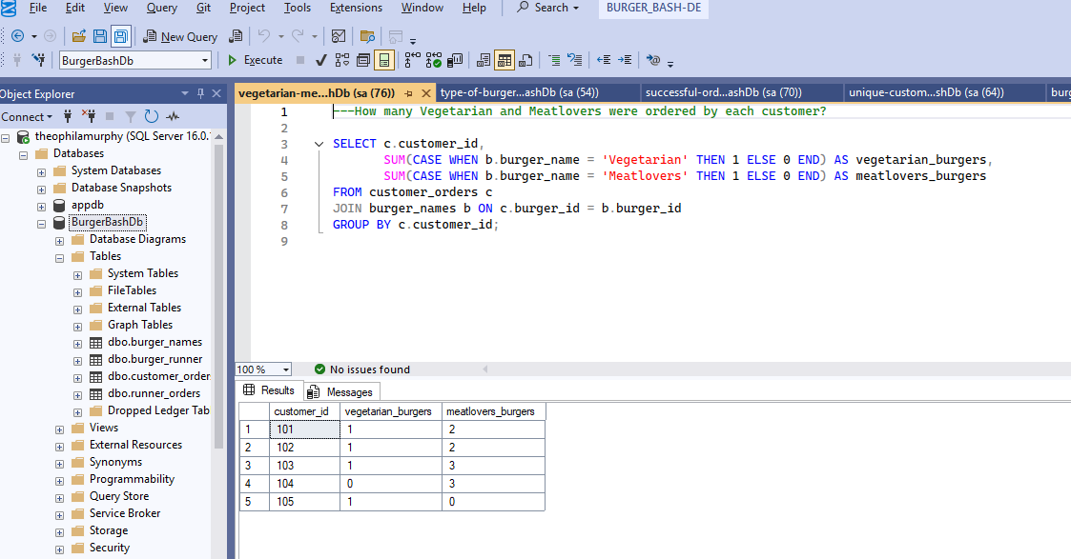

**6. What was the maximum number of burgers delivered in a single order?**

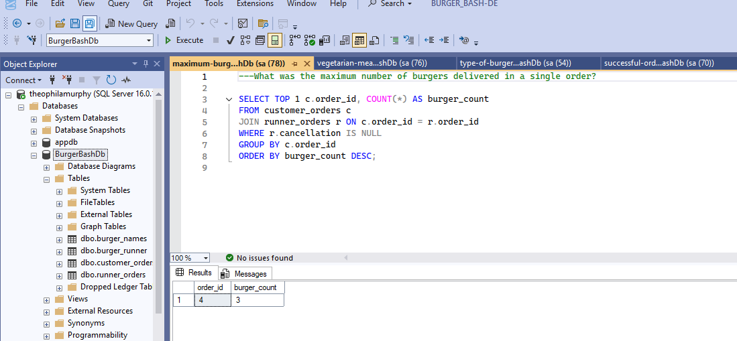

**7. For each customer, how many delivered burgers had at least 1 change and how many had no changes?**

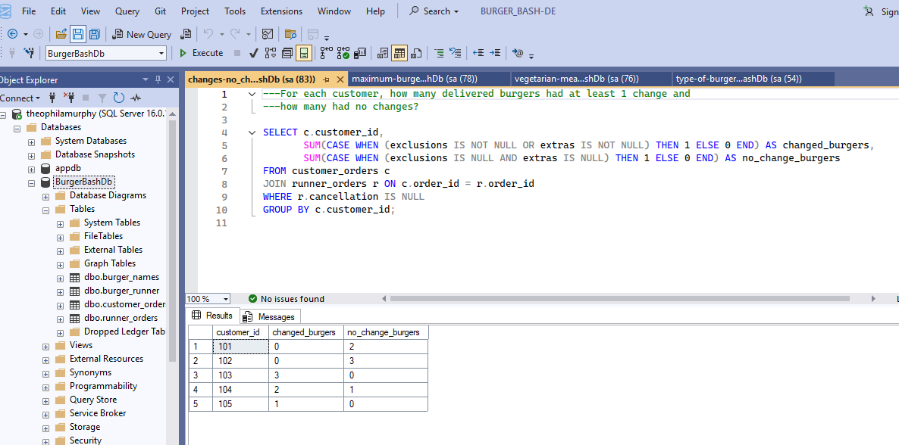

**8. What was the total volume of burgers ordered for each hour of the day?**

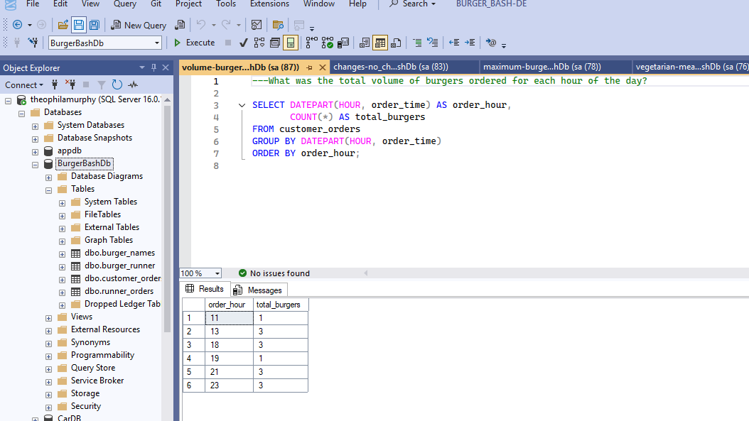

**9. How many runners signed up for each 1 week period?**

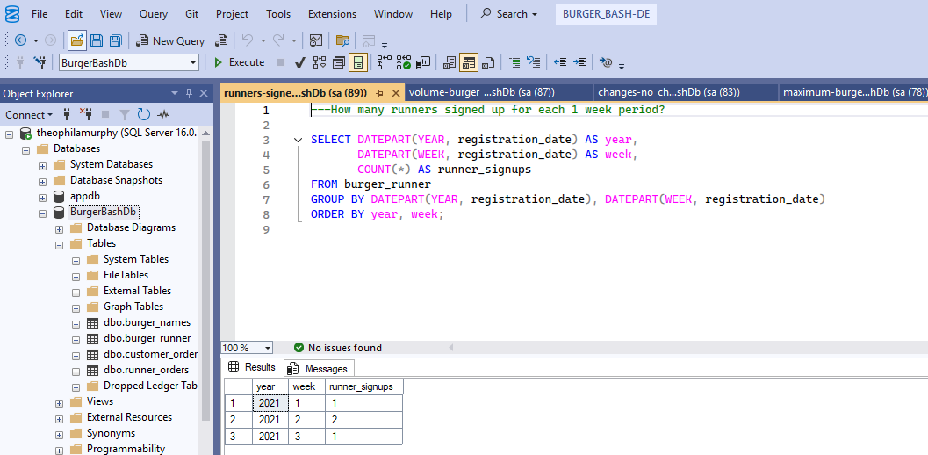

**10.What was the average distance travelled for each customer?**

